

University of Cincinnati

College of Engineering and Applied Science

Implementing Monte Carlo Localization with the Lego Mindstorm

Senior Design Project  
Winter-Spring 2011

Seniors

Andrew Larger  
Zihao Lu  
Trevor Plassman  
Matt Schmucki  
Alicia Zwiebel

Advisor

Professor Dan Humpert

# Executive Summary

Autonomous systems are being developed to do more activities in many different environments and the Global Positioning System (GPS) is not always the best navigation option. As a Mechanical Engineering Senior Design project, this idea was used as an inspiration for the development of a robot that could use Monte Carlo Localization (MCL) to find itself within a given environment with known boundaries and landmarks. This project used the Lego Mindstorm and Java programming in order to develop a robot that could localize itself and navigate to a given end destination, using a compass and sonar sensor. A course was developed and built of plywood with set boundary dimensions and additional, movable walls for variability. The robot was also built to alleviate interference and error from the sonar sensor and compass sensor being used to aid in the movement of the robot throughout the course. A marble swivel wheel was used to allow smooth, tight turns of the robot.

The programming of the robot required several aspects in order to allow it to run effectively. The brick and computer were programmed to communicate through Bluetooth to effectively run and display aspects of the program. The course was designed to be interactive for easy addition of walls within the course. The program used A* navigation to determine the best path the robot would need to take to arrive at the destination once it had localized itself. The MCL was programmed specifically for the sensors used on this robot, and follows a set of five steps until it converges and determines its location on the course. Several difficulties arose while programming the robot and solutions were determined to correct these issues. Some issues still remain and would be considered for future development of the robot.

**Table of Contents**

Executive Summary 2

**1.** **Introduction** 4

**2.** **Background** 4

**3.** **Development** 5

3.1 Constructing the Course 5

3.2 Constructing the Robot 6

3.3 Programming the Robot 8

3.4 A* Navigation 9

3.5 Programming Monte Carlo Localization 11

3.5.1 Theory 11

3.5.2 Programming MCL 15

3.6 Difficulties 21

3.7 Future Work 22

**4.** **Schedule and Tasks** 25

**5.** **Conclusions** 25

**6.** **References** 26

**7.** **Appendix – Power Point Slides** 27

1. **Introduction**

The objective of the project is to program the Lego Mindstorm to use Monte Carlo Localization (MCL) to allow the robot to determine where it is within a given environment, with known boundaries and landmarks. Once the robot has localized itself within the environment, it will be able to autonomously determine the most efficient and quick path to navigate to the end destination, avoiding the boundaries and landmarks.

1. **Background**

Many robots designed today rely on Global Positioning Systems (GPS) to determine their location. This is not always the best option. GPS is not accurate enough to navigate tight spaces with many close obstacles, nor does it work well, if at all, indoors. Using GPS as a primary system of localization and navigation is not really an option for a robot that will be based primarily indoors or needing to navigate tight courses. For this reason, another version of localization and navigation needs to be explored for application with autonomous systems.

The capabilities of the Lego Mindstorm will be explored for programming a robot to autonomously navigate through the given environment. The robot is able to run a version of Java instead of the provided Lego Mindstorm software, allowing more versatile programming of the MCL algorithms.

The project focuses on using only the Lego Mindstorm, necessary Lego Mindstorm sensors, and the MCL algorithms. The MCL algorithms are developed specifically for sensors being used in this project. The project will stick to using sensors available specifically for the Lego Mindstorm, which ensures a cost effective development. Third party sensors can be cost prohibitive and cause the project to focus on specifying the optimal sensors as opposed to optimizing the programming and imploring creative ways to use the sensors. Focusing on less important aspects of the robot can lead to scope creep which the group aims to eliminate while staying focused on the primary objective and means of obtaining the goals in place for the project.

1. **Development**
   1. Constructing the Course

The robot needed to exist in a world of known exterior boundaries and variable interior boundaries. To achieve this, a large piece of plywood was offered and used as the base for this course. Interior dimensions were taken that would allow for maximum possible area while having perfect 90 degree corners. The dimensions allowed for the total length of the course to be 140 cm and 63 cm tall with a notch cut in one of the long ends 20 cm deep, 20 cm long and centered along the length of the plywood. Once the dimensions were marked off on the plywood base, a band saw was used to cut the piece to the exact dimensions.

The robot needed to be able to get the distances to these edges to accurately perform its task. To accomplish this, walls were measured out, cut with the band saw and screwed in place on these edges standing roughly 10 cm above the base level.

During testing of the robot, it was noticed that the marble on the robot used for turning was picking up quite a bit of resistance from the plywood due to its uneven surface. To smooth this out without creating an entirely new base piece, three pieces of poster board were cut up, laid on the course and then taped together.

With the exterior wall dimensions set, several smaller movable walls were put together to allow for some degree of variability in the course layout. These walls were made at 10, 15, and 20 cm long. The walls stand slightly higher than the boundary walls due to the base nailed on the bottom of each wall to add stability. These bases for the walls do not add additional length to the walls but do add approximately ½ cm of width on either side.

To complete the course, it was decided that it should be made easier to determine the actual location of the robot visually to compare with the results on screen. The poster board pieces were marked up with a 5 cm by 5 cm square pattern to more accurately allow the group to determine visually the robot position on the map; as well as, determine the distances the robot should be reading and displaying. Along the interior walls, labels were then put in place showing the total length of each wall.

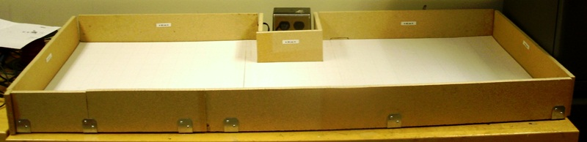

Figure 3.1.1: Completed Course

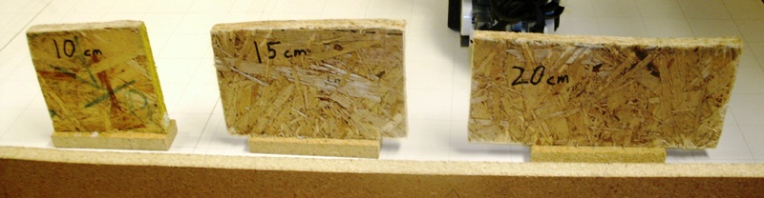

Figure 3.1.2: Mobile Walls

* 1. Constructing the Robot

The robot was designed and built using the Lego Mindstorm and compatible pieces. The major components are the control brick, two motors to control the two wheels, the compass sensor to get direction and allow for accurate 90 degree turns and the distance sensor to determine the distance to the nearest wall approximately straight out from the robot. A non-Lego component was used to allow the robot to turn with the least resistance possible. This piece is a marble held in place by an inverted wheel well. The marble will rotate in place and is located on the back end to balance the robot on three points, including the two wheels.

To design the robot, we first had to account for the two motors we had which would drive the robot, the control brick which would have to be situated somewhere above the motors, and the distance sensor. Our group decided to put the distance sensor beneath the control brick to prevent additional height, which would have required taller walls, as well as, creating more potential variance in the readings if the sensor was angled too far down. Many different methods were attempted to create a rear wheel or wheels which would both balance the robot as well as allow for smooth turning in place. After several weeks, it was decided that a small marble could be held in place by one of the available wheel wells and this would be suffice for both turning smoothly and balancing the robot.

The compass sensor was acquired much later to better facilitate accurate turns of 90 degrees. However, it was discovered that the motors actually created some interference with the compass readings. The solution was to locate the sensor at least 4 to 6 inches away from the motors. Support beams were built up from the control brick to a height sufficient to alleviate these interference issues.

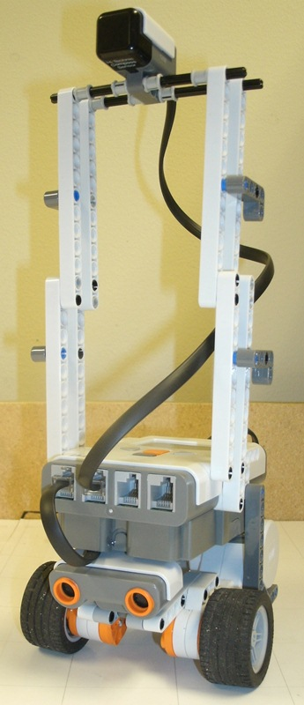

Figure 3.2.1: Completed Robot

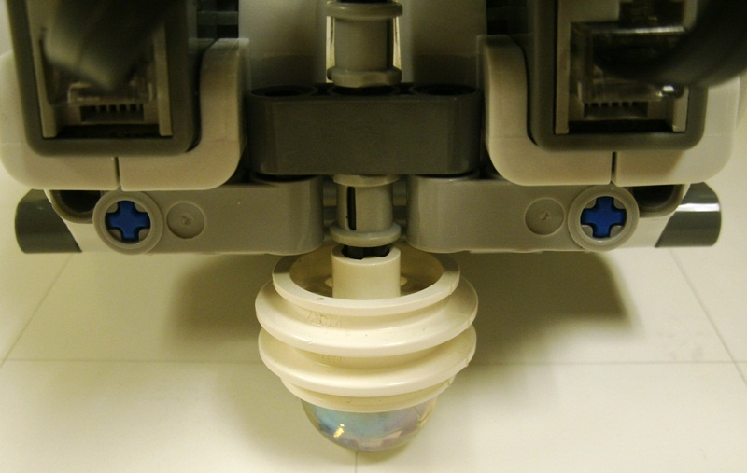

Figure 3.2.2: Marble Wheel Base Design

* 1. Programming the Robot

The Lego Mindstorm came with custom preinstalled software. This software did not meet the needs of the project. It used a block GUI to program the brick and was not robust enough for Monte Carlo Localization. After some research, a Java operating system, Lejos, was found that could be installed on the brick. This system erased what the brick previously had and installed a version of Java. A regular Java programming suite could now be used to program the brick. It is important to note that no one in this group is a computer science major. The group is made up of mechanical engineers and learning how to program at this level was its own challenge.

The first step was connecting to the brick using a Bluetooth connection. The only options were a Bluetooth connection or a USB connection. Using USB would mean the brick would always need to be connected to the laptop. This was a limitation that was not acceptable. It took trial and error to try and open the ports needed to send integers to and from the brick. The key was to get the computer and brick to do the opposite of each other. If one was sending data, the other had to be listening for data. The table below shows what calls the computer would make then what calls the brick would make it response. The segment below would ask the brick to use its sonar and record the distance it reads. The brick then returns this value to the laptop and the laptop then prints it out in the form of ‘temp.’ By passing numbers back and forth, the two computers can be regulated and not override each other.

|  |  |
| --- | --- |
| **Laptop** | **Brick** |
| *conn* = **new** NXTConnector();  *dos* = *conn*.getDataOut();  *dis* = *conn*.getDataIn();  *dos*.writeInt(5);  *dos*.flush();  **int** temp = *dis*.readInt();  System.*out*.println(temp); | *btc* = Bluetooth.*waitForConnection*(); *dis* = *btc*.openDataInputStream();  *dos* = *btc*.openDataOutputStream();  n = *dis*.readInt();  **int** temp = *uss*.getDistance();  *dos*.writeInt(temp);  *dos*.flush(); |

After the laptop was communicating with the brick, the laptop had to create a grid that represented the environment. While the computers may not need this display, the humans running the program needed it so they could understand what the computers were doing. The grid would be identical to the physical course that was constructed. On the screen, 5 pixels is the equivalent of 1 centimeter. In the screen shot below, each small square represents 1 centimeter. The larger squares are 5 centimeters on each side and match the physical course. Any red square represents a wall. The user can easily click a cell to change it into a wall. This screen is interactive.

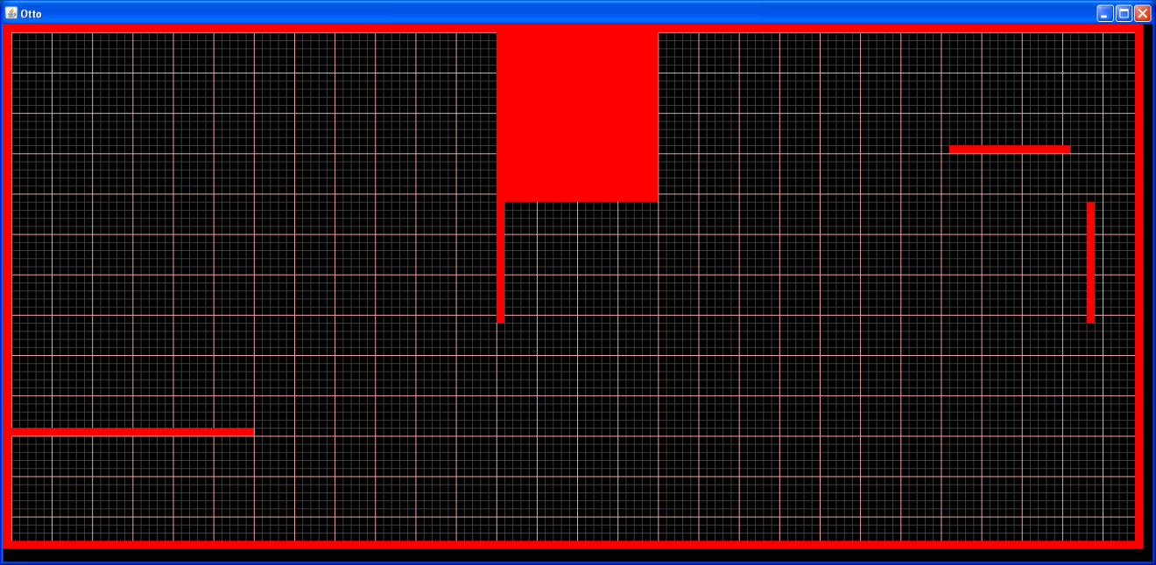

Figure 3.3.1: Screen Shot of User Interface

With the laptop now showing an interface and also being able to communicate with the robot, two major obstacles still existed. The first was localizing itself so it knew where it was. The second was getting it to travel the course once it knew where it was. These two obstacles were divided up among two people on the team.

* 1. A* Navigation

A* navigation was chosen to navigate the robot once it knew where it was. This algorithm was first used in 1968 but was based on a 1959 algorithm created by Edsger Dijkstra [1]. A* uses heuristics to be efficient and effective. Heuristics is often defined as common sense or an educated guess. While it is easy for a human to use common sense, it can be much more difficult to program a robot to use common sense. Heuristics attempts to do this.

This process divides the environment into cells called nodes. Each node is then assigned three costs. The table below talks about each cost. Whichever node has the lowest cost is the best solution.

|  |  |  |
| --- | --- | --- |
| **A* Star Costs** | | |
| Name | Symbol | Description |
| Exact Cost | G | Exact distance from the starting point |
| Heuristic Cost | H | Estimated distance from the end point |
| Total Cost | F | = G + H |

Gamegardens.com provided an excellent example of pseudo code describing how A* is implemented. That portion of code is included below. From this outline, code written in Java and customized to our course was created and could solve how to get from one point to another. The code also took into account walls and how much room was needed for the robot to get by. This was added on our own.

create the open list of nodes, initially containing only our starting node

create the closed list of nodes, initially empty

while (we have not reached our goal) {

consider the best node in the open list (the node with the lowest f value)

if (this node is the goal) {

then we're done

}

else {

move the current node to the closed list and consider all of its neighbors

for (each neighbor) {

if (this neighbor is in the closed list and our current g value is lower) {

update the neighbor with the new, lower, g value

change the neighbor's parent to our current node

}

else if (this neighbor is in the open list and our current g value is lower) {

update the neighbor with the new, lower, g value

change the neighbor's parent to our current node

}

else this neighbor is not in either the open or closed list {

add the neighbor to the open list and set its g value

}

}

}

}

* 1. Programming Monte Carlo Localization
     1. Theory

To begin Monte Carlo Localization (MCL), the processing computer must generate a large number of theoretically random possible poses, consisting of location and heading, within a known boundary environment which represent the possible locations that the robot may occupy. These can be thought of as the computer’s random guesses at where the robot might be within the known boundary. In actuality only one of these poses represents the actual location of the robot, but at the beginning each pose generated by the computer has an equal chance of being the correct location.[4]

In order to eliminate certain poses, the robot must move to a new location, update its current pose guesses and then resamplethe poses in a manner which keeps only those poses which have the highest possibility of being the correct location. [5] This possibility of being the correct location is known as the pose’s weight. This weight is found by monitoring the difference between a sonar reading from the robot to the nearest obstructions and the pose property that represents this reading for each pose. The closer the pose reading to the nearest obstruction is to the robot’s reading the higher the weight of that pose and the more likely it is the correct guess at the robot’s location. Repeating this resampling process over the course of several random moves applied to the robot and the poses will eventually converge all of the poses into a single location that, based on the pose weight, has the best chance of representing the location of the robot.

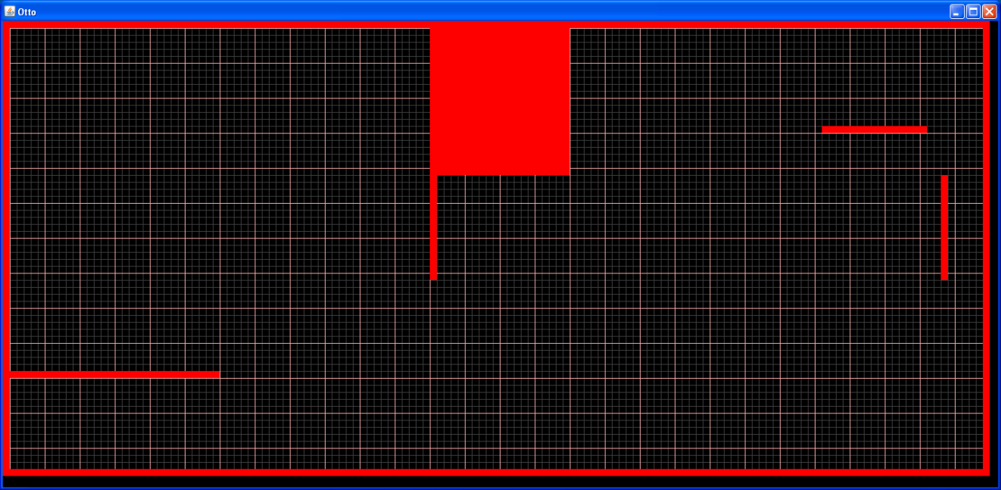

Figure 3.5.1.1: Initial Boundary

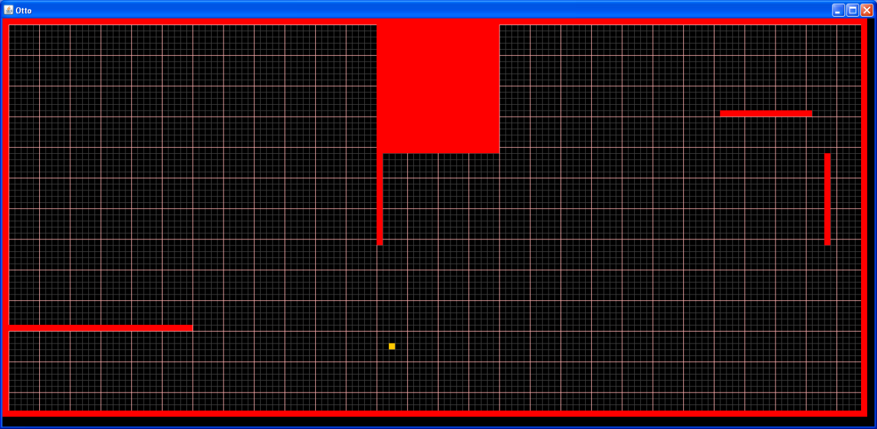

Figure 3.5.1.2: Initial Boundary with End Point Selected

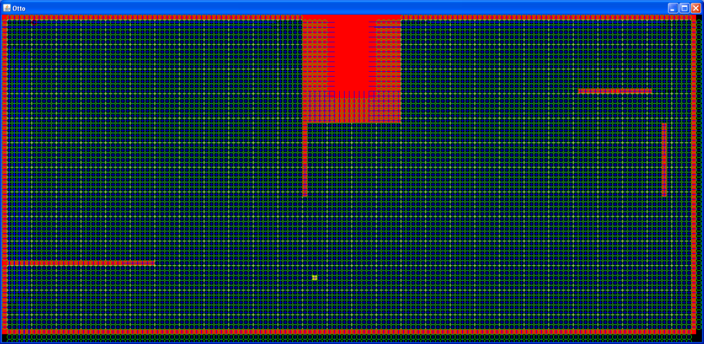

Figure 3.5.1.3: Initial Particle Population

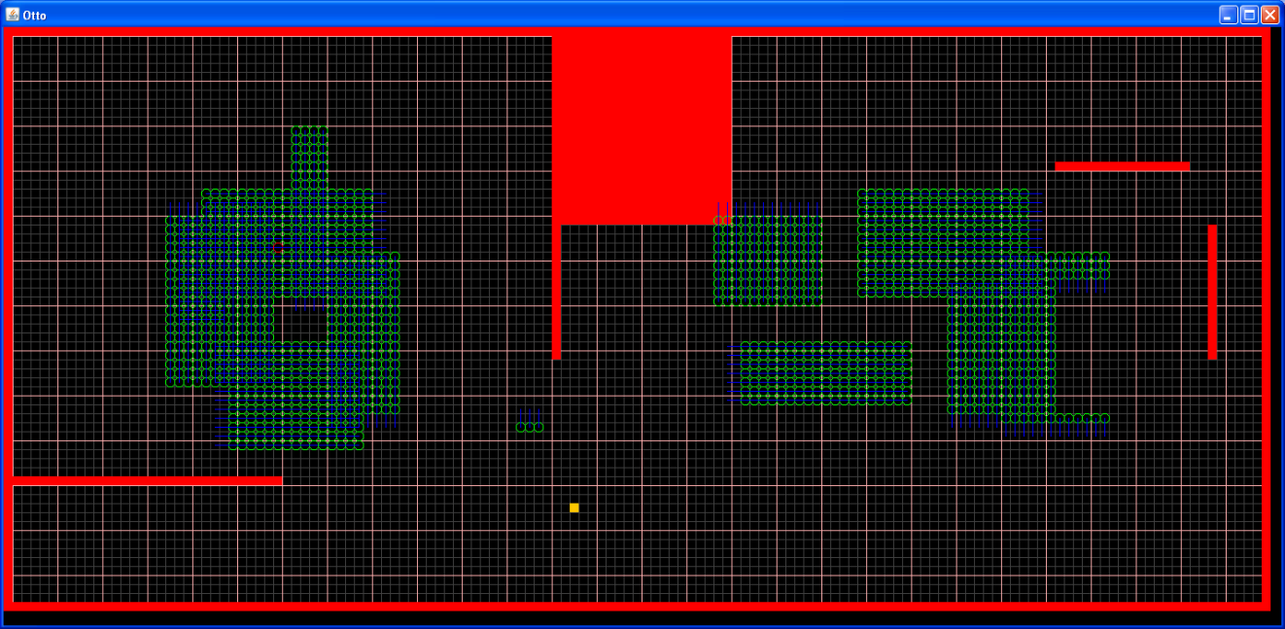

Figure 3.5.1.4: Converging Particles Resample 1

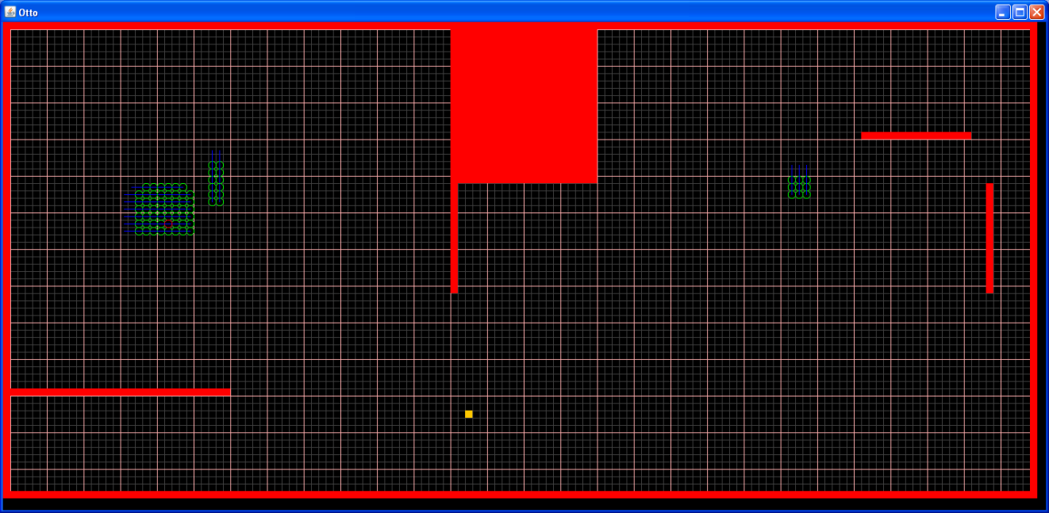

Figure 3.5.1.5: Converging Particles Resample 2

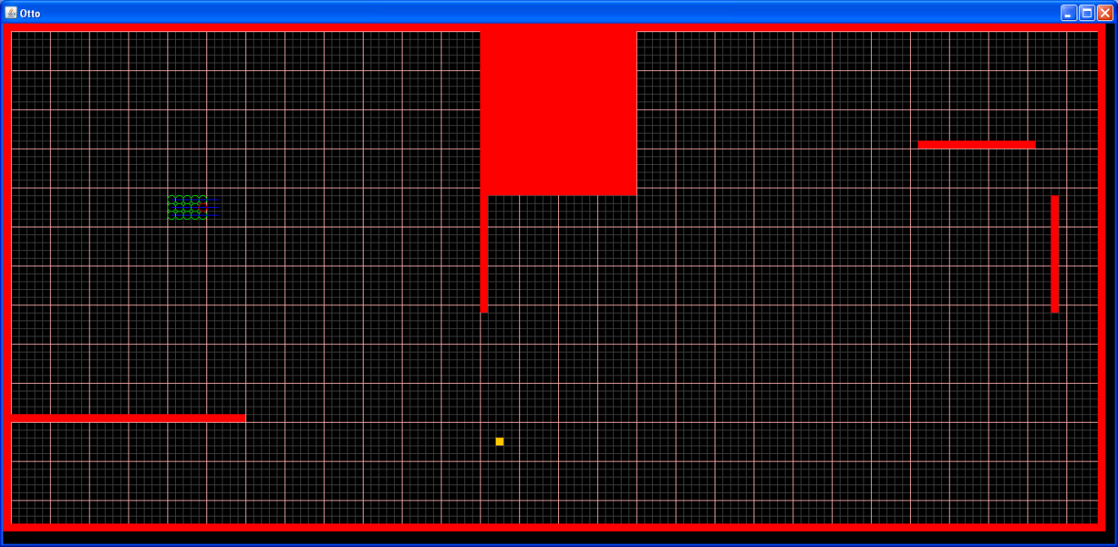

Figure 3.5.1.6: Converging Particles Resample 3

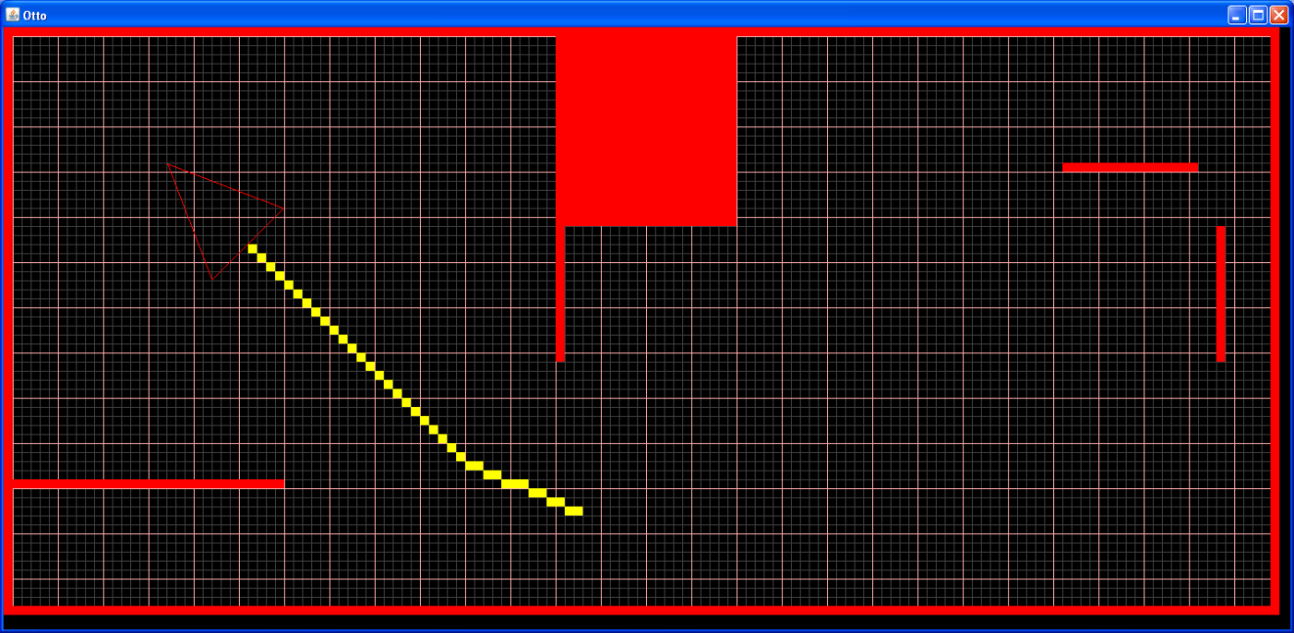

Figure 3.5.1.7: MCL Localization Complete

* + 1. Programming MCL

The Lego NXJ robot programming very closely followed the MCL theory with a few minor customizations to optimize the process for this specific project. All computation was completed on a laptop PC while the robot simply completed the moves sent to it from the PC code and sent back the sonar readings to the nearest obstruction in the known environment. The PC and robot communicated over a Bluetooth connection with a simple communication protocol uploaded to the robots processing unit (NXJ brick).

The PC program followed a series of simple steps that will be outlined below and are broken down into more detail in their corresponding sections. These steps included:

1. Generate Particles: Generating the pose set to represent the computer’s guess at the possible locations of the robot.
2. Apply Move: Applying a move to the robot and to the poses in order to update the guesses of the computer at the robot’s location.
3. Take Reading: Taking a sonar reading from the robot to be used in the weight calculation for the poses.
4. Calculate Weight: Comparing the sonar reading from the robot to the known reading assigned to each poses and calculating the possibility that this pose is the correct guess at the robots location by analyzing the difference between these readings.
5. Resample: Updating the pose sets through a resampling process which checks if a given poses has a weight calculation higher than a random number in a specified range and if true, creating a copy of this pose so that its chances of being the correct robot location increase in the next sample.
   * + 1. Generate Particles

The process of standard Monte Carlo Localization (MCL) begins with the computer generating a random set of poses consisting of location and heading to represent the possible locations that the robot may occupy. To customize the project to limitations of the hardware, a special pose class was created in Java with specific methods defined for interacting with each pose as well as retrieving information. For the purposes of this project the MCL code required that four poses be created in each cell defined within the environment. These four poses had the same x and y coordinates, however they each had a unique heading in one of the four cardinal directions (East: 0°, North: 90°, West: 180°, South: 270°). Note that this is greatly simplified from standard MCL as the headings of each pose are limited to only four different directions. This was due to the fact that the Lego Mindstorm sonar sensor was only capable of taking readings at locations perpendicular to the environment borders which for this project were all square. The poses were also defined by four integers in each of the cardinal directions representing the distances from each pose to the nearest obstruction. The code defining this process can be found in an additional file in the otto.java class file under the method “generateParticles()”.

* + - 1. Apply Move

After the pose sets have been created through the particle generation method, the MCL algorithm requires that the robot make a series of moves in order to begin the process of converging the poses. For the purposes of this project, the move called is a 90° rotation to the right and then if possible a forward move that covers a random integer distance between 1 and 6 centimeters. After each rotation the robot will go through the other steps of taking a reading, calculating the weight of each pose and then resampling the pose set as described in the section below. After the reading to the next obstruction is taken, however, the robot decides whether it has enough room to make a forward move. This is decided by checking to make sure the nearest obstruction is at least 20 centimeters ahead of the robot. If this condition is true then the robot knows it has enough room to make a forward move and then turn again. The purpose of making forward moves in between turns is to help the poses converge quicker by creating greater variance between the robot reading and the pose reading. This process of changing the move type also helps to eliminate local symmetry within the environment.

Applying the move to the robot involves selecting a number between 1 and 4 according to the move protocol defined by the Bluetooth communication file that is uploaded to the robots computing unit (1: Forward, 2: Backward, 3: Left, 4: Right). It is also important to note that the move that is applied to the robot must also be applied to each pose that is contained in the pose set. Applying this move to the poses means not only updating the x and y coordinates based on the pose heading but also updating the integers in the pose representing the distances to the nearest obstruction in each of the four cardinal directions. Updating these is also based on the heading of the poses which is itself changed with each turn move completed. The code for applying moves to the poses and robots can be found in the “applyMove()” method in the otto.java file as well as the “applyMove()” method in the Pose.java class in the additional file.

* + - 1. Take Reading

The take reading method is used for the sole purpose of telling the robot to take a sonar reading to the closest obstruction. It is accomplished by using the communication protocol previously discussed where the integer 5 is sent to the robot and tells the sonar sensor to take the reading and the data out stream flushes the reading from the robot to the PC. This method must also be paired with a while loop in which the reading must be less than 255 to break the loop and continue with the MCL algorithm. The method for taking the reading can be found in the “takeReading()” section of the otto.java file with its implementation being in the “solve()” method of the otto.java file.

* + - 1. Calculate Weight

The calculate weight method is used to determine if a given pose is a good guess at the actual position of the robot. This weight calculation begins with a difference squares difference between the reading that the robot takes from the sonar sensor and the particle reading of the pose as a function of its heading as defined by the equation $diff=\sqrt{abs\left(robotReading^{2}-particleReading^{2}\right) }$. This difference is then used in the equation $weight=1/ (1+(\frac{diff}{robotRead}))$ to normalize the value such that the weight will always be a number between 0 and 1 with the smallest differences yielding the highest weights.

Using a difference square difference method was shown to be superior to simply using a percentage difference method defined by the equation $diff=abs(robotReading-particleReasing)/robotReading$ [5]. This is due to the fact that the squared difference method copies more poses with smaller difference and less poses with larger difference in an exponential fashion while the percentage difference method is mostly linear in its selection of poses. This can be seen in the excel plots below where the Current line represents a linear selection and the Squared line represents the exponential selection. Note that this test was done for selection of higher weighted poses for both long and short differences in distance.

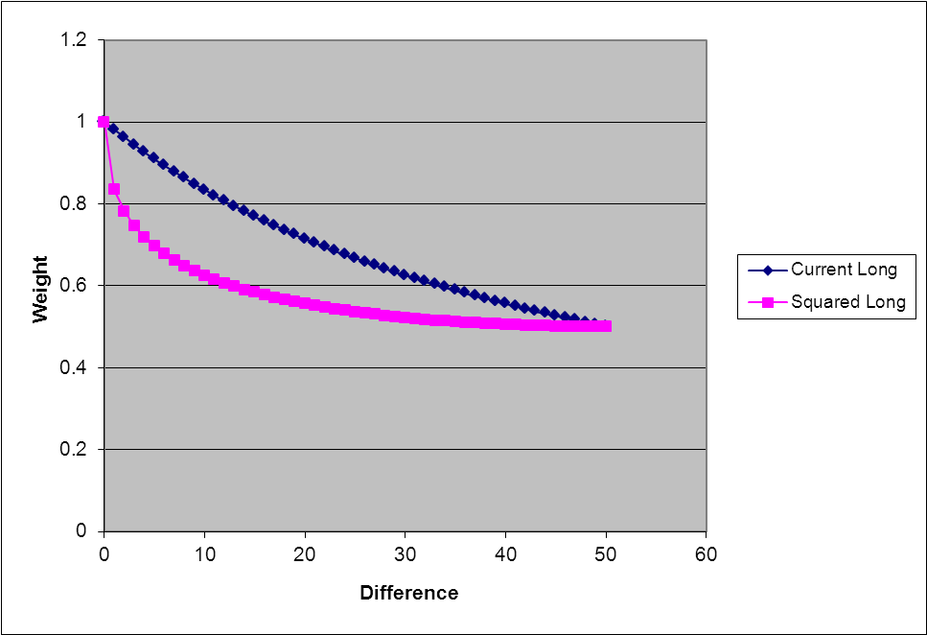

Figure 3.5.2.4.1: Weight Calculation Comparison, Long

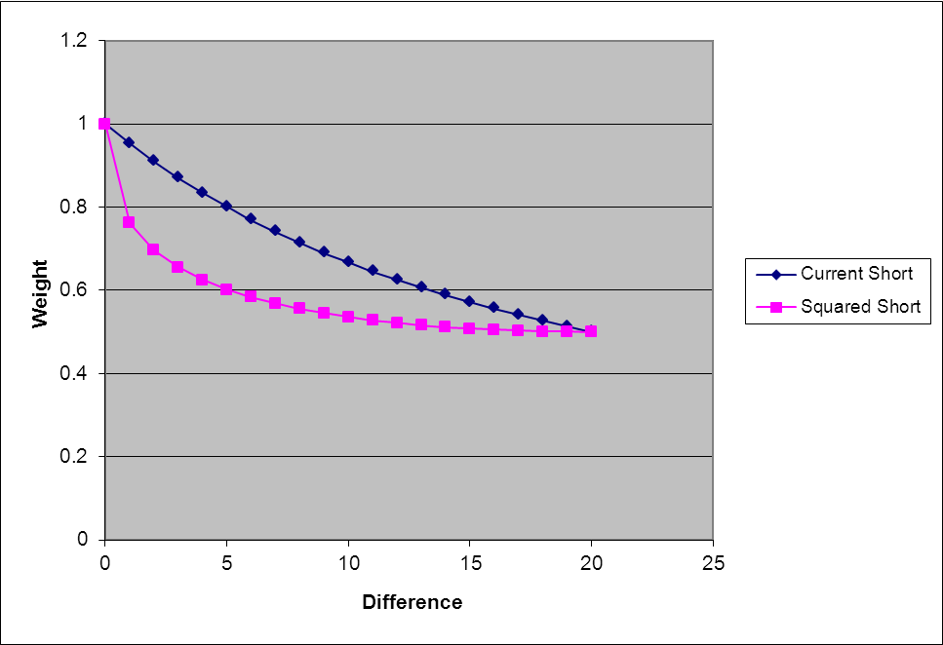

Figure 3.5.2.4.2: Weight Calculation Comparison, Short

Another advantage to using this method is that is helps to compensate for compounding physical movement errors accrued in the process of having the robot make multiple moves before convergence. One important realization in the project was the idea to use modular math in reference to the angles when selecting the particle reading to be used in comparison with the robot reading. This is because the angle or heading of the robot and thus the particles may exceed 360 degrees depending on how many turns it takes to converge the pose set. Using modular math with respect to the heading will always keep this heading between -360 degrees and 360 degrees which can be handled more easily by the MCL computations. The specific code used for this section can be found in the “calculateWeight()” method of the Pose.java class found in the additional file.

* + - 1. Resample

The resample method in the MCL algorithm uses the weights of each pose to decide what particles from the original pose set will be copied into the new pose set that will define the next round of moves and resampling. The logic of this resampling is as follows:

* The original pose set is copied into a new temporary pose set that will be used as a reference to copy poses and is then cleared
* A while loop is created and is set to break only when the new pose set that will be created is of the same size as the original pose set.
* A random number between 0.5 and 1 is selected and then used as the lower limit of the weight filter used to screen each particle in the temporary set.
* If the particle being analyzed has a weight that is greater than the random number a copy of this particle is placed into the new set and the loop continues to the next particle until the size of the new pose set if the same as the original pose set.

This method causes multiple instances of high weight poses to be created in a pose set of a constant size while the poses with too low of a weight based on their particle readings compared to the robot reading will be eliminated from the pose set representing the guesses at the robots location. The code for this section can be found in the “resample()” method of the otto.java file in the additional file.

Note that this entire process for converging the location guesses is run until the number of poses that are the same is at least 25% of the total pose set size. This number was determined after multiple trials of MCL where the solution was reduced down to a reasonable cluster but failed to converge to one specific location due to low weights as a result of errors in the robots physical movements. 25% of same particles is a high enough factor of the total pose set size to constitute a majority of particles.

Some of the limitations of using this method are that the more moves needed to reduce the possible locations of the poses, the more error that will be introduced into the readings based on physical errors involved in the robots movement. For this reason the convergence criteria can be altered to optimize the solution to limit the number of moves needed to reduce the number of possible locations and thereby increase the number of same poses in the pose set.

* 1. Difficulties

During testing, a number of difficulties arose which hindered our group’s results. One of the earliest problems encountered involved designing a rear swivel wheel component that would allow the robot to rotate in place. This problem was compounded by the relatively small number of pieces to choose from amongst the available Lego pieces. After a few weeks of attempts, using strictly the pieces available, the group decided to use a marble held in place by a wheel well that would allow for sufficient rear support while not interfering with rotation.

Additionally, the sonar sensor does not read straight out in front of it; it reads at a wide angle and then returns the distance to the nearest of the objects. So while the straight line distance to the wall may be X, a wall off to the side may only be X/2 and the localization program might then interpret the robot to be in front of that wall instead of the actual location.

Furthermore, the robot has a tendency to not rotate by a perfect 90 degrees each time, causing it to read distances at the longer angle instead of the straight line intended. This issue was largely solved with calibration of the compass sensor and moving the sensor further away from the robot, but the problem was not solved entirely. It was also noted that as the robot traveled over longer distances it would tend to drift, seemingly based on the compass bearing.

Like most programming projects, trial and error was used with almost every step. For the Bluetooth connecting, the parameters had to be isolated and used step by step to ensure the team understood what was happening and where the code was breaking. It was discovered that the Bluetooth Stack that came on the laptop being used was not compatible so different software had to be used.

All of the components in the GUI are measured using pixels. The robot moved in millimeters. The team worked in centimeters. This created room for error and conversion mistakes. There were several times a number was in pixels when it needed to be in centimeters. Having the program display the values enabled us to see what was happening and to correct for these errors.

Monte Carlo had several errors with how it calculated its weights and found a percentage. Because of the scale of these errors, it was discussed in the Monte Carlo section of this paper.

* 1. Future Work

One of the largest potential sources of error at this point is the sonar sensor reading the distances to the nearest wall. In theory, it should be reading the distances straight out from the robot. In actuality, the sonar sensor will return the distance to the nearest object it finds out to a fairly wide angle. So for example, the robot may be 30 cm away from the nearest wall straight out from it while there is another wall 20 cm away but off to either side. The sonar sensor will read the distance as 20 cm and update the localization routine accordingly, thus introducing an increasingly significant amount of error every time it takes a reading like that. To combat this, one possible solution is to have the robot travel towards a wall until it is nearly in contact with it, possibly within 5 cm. However, the robot could then find itself in a position where there are obstacle walls on either side of it. At this point the robot would either have to backtrack its path completely or would have to have sonar sensors on the left and right side to read distances and determine if it is possible for the robot to turn in its current position or backtrack itself. Alternatively, the single sonar sensor used now may be attached to a motor that will allow it to rotate to get distances from all directions. This would allow it to know at the initial startup if it is located too near to a wall on any side to attempt to move or rotate in that direction. Doing this would require fairly significant rework of the programming but would make the robot much more versatile in all possible environments.

Once the robot localizes itself, the current programming has it travel to a pre-specified point on the course. It accomplishes this by creating a line of travel from its localized position to this point by the shortest route possible. But, as it travels this path, it currently takes no position/distance readings to verify it is remaining on path. As such, it may occasionally run into a wall or obstacle in its path and continue driving the wheels as if it were still on course. To solve this problem, the distance and compass sensors would need to take readings as it travels the path to confirm it is still on target. Reprogramming the route drawing parameters may help as well if instead of travelling at diagonals it traveled only in straight lines perpendicular to the walls. As the robot currently takes all readings while perpendicular to the walls during localization already, this solution would make it far easier for the robot to stay on course and travel to the destination much more accurately.

Symmetry problems are also an issue the robot might be facing. In some cases, the group found that the converging of the algorithm in these symmetry points in the map were very slow and sometimes were even impossible. In this case, the robot will lose its direction and get stuck. To solve this problem, a few methods can be considered that can be added for future development. The first possible method is increasing the measuring direction from four main directions to eight or even more directions in order to reduce the number of potential symmetry points. By getting more measurements from angles other than 0 degrees, 90 degrees, 180 degrees, and 270 degrees, more localization information can be available and referred to make more accurate convergence. The second possible method for solving the symmetry problem is by analyzing the map before the robot starts to self-localize itself (the map initialization) in order to find out the possible symmetry points and particles in the whole map. The robot can then come up with potential backup routes, such as finding a specific corner or a wall in the map. The robot could then pick one of the possible routes as an alternative. During this, the program should also be designed to compare the real time measurements with the particles in the database in order to rule out locations. Another possible solution is to add other sensors, such as a simple north pointer sensor, for reference to avoid the symmetry in the map.

Other than improving accuracy of the sonar sensor, the calibration of the compass, and way of analyzing the map mentioned before, the algorithm is another aspect that can be improved, such as the algorithm of ‘Calculation Weight’ and ‘Grid Size’ of the map. A better algorithm should speed up the whole procedure of converging.

As the robot attempts to travel in a straight line for more prolonged periods of time, it tends to drift. This may be a function of the robot not turning a perfect 90 degrees, one motor possibly being either more powerful or not calibrated as accurately as the other, the wheels being slightly bowed under the weight of the robot, or more likely, a combination of all of the above. While the robot is in motion, the programming assumes that it is traveling in a straight line from point A to point B. What actually happens, though, is the robot travels from point A to point C and it believes it is at point B, thus adding an escalating degree of error in the robot’s localization routine. To correct this, several steps need to be taken to correct each issue. The motors have to be accurately calibrated to make sure they are turning at the exact same rate for the exact same amount of time. Further calibration of the compass sensor, used for the 90 degree turns, needs to happen along with further shielding of it from interfering elements in the motor and control brick. The base supporting the wheels needs to be strengthened and the possibility of adding two rear wheels to replace the marble but add additional weight distribution should not be ignored. These wheels would have to be able to turn in place to facilitate zero point turning radius. Alternatively, a second marble could be added with their locations being shifted to the rear outside edge instead of centered at the rear of the robot.

1. **Schedule and Tasks**

A timeline had been laid out for the development of the robot. This timeline was followed during the development and different tasks assigned to the group members.



1. **Conclusions**

After extensive research, development, programming, and trouble shooting, the overall goal of the project was achieved. The Lego Mindstorm robot is able to localize itself within the given boundaries and random placement within the course. Once it determines its position, the robot can determine the best path to precede to its final destination while avoiding obstacles, and then precede along that path.

There are still minor errors and issues that occur and would need further development if the robot is pursued. These errors and problems would be improvements upon what has already been developed by this project and would allow some optimization of the current system. The development of the program has been a learning experience for the benefit of the group’s autonomous system knowledge.

The project followed a schedule and was able to complete the project in a timely manner based on that schedule. The group worked cohesively to prepare all aspects of the project, including hardware (course, walls, etc) and software development.

1. **References**

[1] "A* Search Algorithm." *Wikipedia, the Free Encyclopedia*. Web. 07 June 2011. <http://en.wikipedia.org/wiki/A*_search_algorithm>.

[2] "Path Finding Tutorial - Gardenwiki." Main Page - Gardenwiki. Web. 07 June 2011. <http://wiki.gamegardens.com/Path_Finding_Tutorial>.

[3] Lester, Patrick. "A* Pathfinding for Beginners." Almanac of Policy Issues. 18 July 2005. Web. 07 June 2011. <http://www.policyalmanac.org/games/aStarTutorial.htm>.

[4] Clemency. LEJOS: Programming the NXT in Java. 2009. April 2011

<http://lejosnxt.blogspot.com/>

[5] Lawrie. Monte Carlo Localization. 12 May 2008. April 2011

<http://lejos.sourceforge.net/forum/viewtopic.php?=6682

1. **Appendix – Power Point Slides**











